Jayawardhana A.T.G - IT2120

Exercise 2

(1)

1.

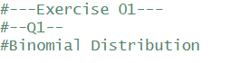

2.

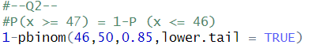

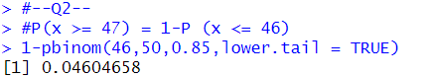

(2)

1.



2.



3.

